



Solution Design Document

SmartForm

Version1.0

**January 31, 2019**

Document History

|  |  |  |  |  |
| --- | --- | --- | --- | --- |
| Revision | Description | Date | Prepared By | Reviewed By |
| 1 | Initial Draft | 31/01/2019 |  |  |

Table of Contents

1 Introduction 4

1.1 Document Purpose 4

1.2 In Scope 4

**1.3** **Out of Scope** 4

**1.4** **Relevant Documents (Current Situation/Environment)** 4

**1.5** **Assumptions** 5

**2** **Systems Overview** 5

**2.1** **Applications and Systems** 5

**2.2** **Applications Interfacing** 5

3 Analysis 6

3.1 High-level components 6

**3.2** **Narrative Use Case and Detailed Process** 6

**3.3** **Requirements** 7

7

4 Inputs and Outputs 8

4.1. Inputs 8

4.2. Outputs 8

5 Assets 8

**6** **Robot Schedule** 8

**7** **Workflow Modules** 8

1. Conversion Flow (Phase 1) 8

2. Employee ID present flow (Phase 2) 8

7.1 Exceptions 9

**8** **Logs** 9

**9** **RE-Framework Reusable Components:** 9

**10** **Coding Standards** 9

**11** **Frequency** 10

**12** **SLA** 10

**13** **Report Generation** 10

# Introduction

This document will provide solution and technical design of Data Management - SmartForms.

## Document Purpose

The purpose of this document is to explain the technical design and overview of SmartForms implementation for the Data management.

Its main purpose is to –

* Provide the link between the functional specification and the detailed technical design documents
* Detailed functionality provided by each component or group of components and show how the various components interact in the design
* Provide a basis for Smart Forms detailed design and development
* This document is not intended to address installation and configuration details of the actual implementation. Installation and configuration details are provided in technology guides produced during project

As is true with any high-level design, this document will be updated and refined based on changing requirements.

## In Scope

* All transaction for Data management which includes Personal and Job changes
* Transactions for Individual and Bulk data change request.

Happy Path:

Below request are eligible for self service

* Request with valid data and no approvals needed

Below request are eligible for automation

* Individual and Bulk data request with valid data and with provided approvals

Exceptional Flows:

*Requests in the automation queue can be moved to TT

* 1. **Out of Scope**
* Request with no valid data
* Requests with pending approvals
  1. **Relevant Documents (Current Situation/Environment)**
  2. **Assumptions**
* Employee data is accurate in people portal at the time its fed onto Smart form
* There is a regular feed (need to decide frequency) from people portal to Smart form.
* Associate data will be managed in PeopleSoft. Export of data will follow existing global standard processes unless otherwise specified in the requirements
* If a population group is not listed in the requirement, that population group is not applicable/out of scope.

1. **Systems Overview****­­**

This Section depicts the Application/System being used in current process and what Application/System will be used after automation implementation.

* 1. **Applications and Systems**

|  |  |
| --- | --- |
| Applications | URL *(if any)* |
| SmartForms | Dev:  Test:  Prod: |
| PeopleSoft | Dev:  Test:  Prod: |
| Remedy | Dev:  Test:  Prod: |
| RPA / UiPath | Dev:  Test:  Prod: |

**Type of access required – SSO, credentials etc.**

* 1. **Applications Interfacing**

|  |  |
| --- | --- |
| Applications/Systems | Interfacing mechanism |
| SmartForms | Through Smart Forms UI |
| PeopleSoft |
| Remedy TT |
| RPA / UiPath |

# Analysis

## High-level components

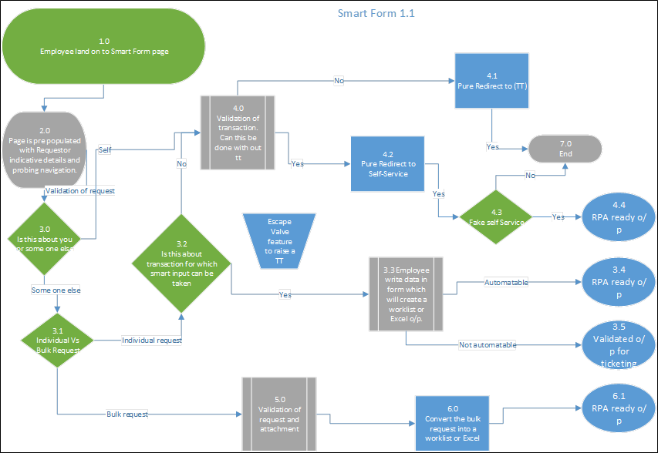

* 1. **Narrative Use Case and Detailed Process**

|  |  |
| --- | --- |
| Use Case Name | Data Management - Smart Forms |
| Goal in Context | Smart Form is a dynamic web-based form solution used to collect, navigate, validate and to eliminate manual work, defects with automation |
| Pre-conditions | User entered data should be valid and must fulfill the requirement of automation |
| Success End Condition | People soft will be updated with user entered data either through self-service or automation |
| Primary Actor | Smart Form, RPA and PeopleSoft |

* 1. **Requirements**

**GUI / SCREEN DESIGN FOR WEB APPLICATIONS:**

| **GUI Aspects** | **Considerations / Alternatives** | **Details and (optional) Rationale** |
| --- | --- | --- |
| Usage of Frames | Yes / No |  |
| Usage of Style sheets (CSS) | Yes |  |
| Sitemap | No |  |
| Menu organization and Navigation | Top Menu |  |
| Technologies | HTML5, CSS3, Angular6, Bootstrap4 and NodeJs |  |
| Colour Scheme | Single scheme for all pages |  |
| Images and their size and quality | PNG / JPEG  Size |  |
| Max page size | Kbs |  |
| Usage of Page ID apart from Page title | Not required |  |
| Screen Resolution | 1366x768, 800 x 600, 1024 x 768 , 1024×576, 1152×648, 1280×720, 1366×768, 1600×900, 1920×1080 |  |
| Browser support | IE 10+, Chrome, Firefox, Safari |  |
| Validation | Common validation / Individual validation |  |
| Error message display locations | TBD |  |
| Search Facility and Technology | NA |  |
| Support for search engines | NA |  |

**INTEGRATION DESIGN FOR WEB APPLICATIONS:**

|  |  |  |
| --- | --- | --- |
| **Integration Aspect** | **Consideration/ Alternatives** | **Details and (optional) Rationale** |
| Restful web service | Yes/No |  |
| API to prepopulate Smart Form | Yes/No |  |
| API to write data into local Data base | Yes/No |  |
| API to fetch files from People soft and update local data base | Yes/No |  |
| API to create ticket in Remedy | Yes/No |  |
| Technologies | JDK 1.8, Spring 5, Maven, Eclipse, SVN/GitHub, Tomcat |  |
| Validations | Common validation / Individual validation |  |
| Error message | TBD |  |

CODING:

| **Code Element** | **Considerations / Alternatives** | **Details and (optional) Rationale** |
| --- | --- | --- |
| Documentation | Angular.io |  |
| HTTP Method | GET, POST |  |
| Common Header & Footer and Includes | Yes |  |
| Session Cleaning |  |  |
| Database Connection |  |  |
| Screen Validations | Date, Trim, Maxsize, Browser Compatibility, Format, Field type |  |
| Security | Restricting intermediate URL access for valid & invalid users |  |
| Folder/ Package Structure | Yes |  |

CODING:

| **Code Element** | **Considerations / Alternatives** | **Details and (optional) Rationale** |
| --- | --- | --- |
| Documentation | Spring.io and Java Docs |  |
| Web Services | Restful/ Soap |  |
| Session Handling | SSO |  |
| Database Connection | MySql - JDBC |  |
| Security | Restricting intermediate URL access for valid & invalid users |  |
| Folder/ Package Structure | Yes |  |

*Final Solution design will be ready once the clarification is received.

# Inputs and Outputs

## 4.1. Inputs

* User entered data either Individual or Bulk data through SmartForm

## 4.2. Outputs

* User request can be self-service or automated through RPA and data will be updated to PeopleSoft

# Assets

* API to consume and to perform CRUD operations on PeopleSoft user data

1. **Robot Schedule**

NA

1. **Workflow Modules**

## SmartForm Workflow

* Employee land on Smart Form page
* Page is pre-populated with requestor indicative detail and probing navigation
* Is this about you or someone else
* Individual Vs Bulk Request
* Is this about transaction for which smart input can taken
* Employee write data in form which will create a worklist or Excel o/p
* RPA ready o/p
* Validated o/p for ticketing
* Validation of transaction. Can this be done without tt
* Pure Redirect to (TT)
* Pure Redirect to Self- Service
* Fake self Service
* RPA ready o/p
* Validation of request and attachment.
* Convert the bulk request into a worklist or Excel
* RPA ready o/p
* Escape Valve

## Exceptions

|  |  |
| --- | --- |
| Exception | Description |
| Application Exception | Peoplesoft / Salesforce applications are down |
| Business Exception | Yet to receive from the Client |

1. **Logs**

* TBD

1. **Reusable Components:**

* Services for Meta data
* Services for CRUD operations

1. **Coding Standards**

* Maintain proper folder structure
* Divide the process into number of angular modules based on application type and functionality
* Avoid hardcoded delays
* Avoid defaults/ constants
* Configurable variables/properties can be used from Configuration file
* Proper naming conventions for variables and sequences
* Handle exceptions for all negative scenarios

1. **Frequency – Put in Scheduling section**

* NA

1. **SLA- Put in Scheduling section**

SLA is to verify all the applications received on the same day (TBC)

1. **Report Generation**

NA